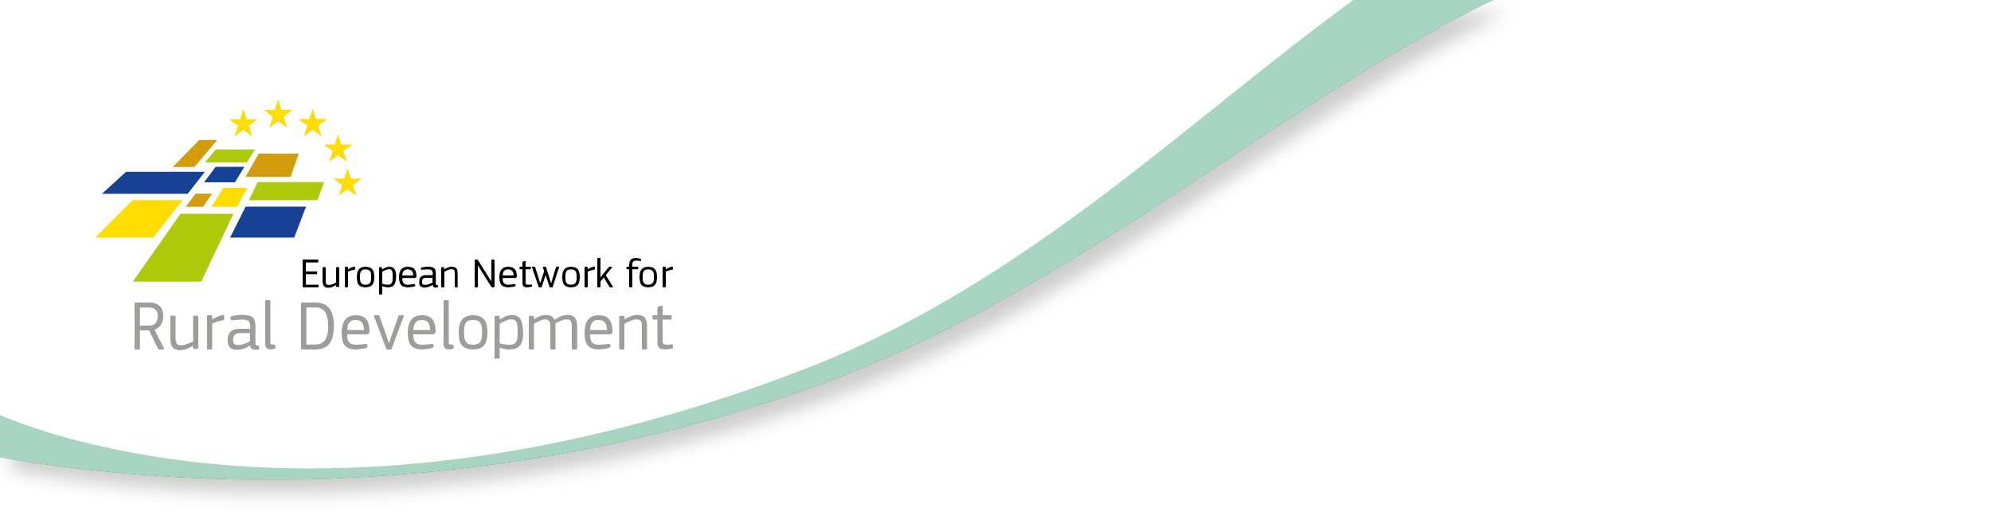

CLLD Cooperation OFFER

Title of the proposed project (English)
Cultural activities and cultural heritage as a tool of community integration

Type of project (select as many as you want)
Cooperation within the MS  ☐ Across regions  ☐ Within the same region | Transnational cooperation  ☒ Cross-border cooperation  ☒ With other MSs (no shared border)  ☐ Non EU countries | Sea basin cooperation  ☐ Mediterranean  ☐ Baltic  ☐ North Sea  ☐ Atlantic

Brief summary of the project idea (max 800 characters)
We are searching for a UE Partner to implement cultural project. The main idea and goal is to make inhabitants more active in creating or taking part in cultural life of the region. We planned a cycle of 5 workshops (4 implemented by Polish LAGs, 1 by the UE partner) where our participant will learn how to make art, their creativity will be wakened so they will be prepared to make cultural projects in their own societies. Their project will take part in a contest during the project’s grand finale and the authors of the best one will be awarded with the special prize which is a participation in the abroad study visit (to our UE partner’s country). It is possible to include tourism as a part of the project, but the main subject must be culture.

Looking for partner located in the following types of areas (select as many items as you want)
☒ National / Regional borders  ☒ Inland  ☒ Island  ☒ Lakes and rivers  ☒ Coastal  ☒ Mountainous | ☒ Rural  ☒ Peri-Urban  ☒ Urban  ☒ Small town  ☒ Historic centre  ☒ Densely populated residential area  ☒ Segregated/deprived neighbourhood | ☐ Isolated / remote  ☐ Sea basin  ☐ Mediterranean  ☐ Baltic  ☐ North Sea  ☐ Atlantic

Looking for partner located in areas with the following assets (select as many items as you want)
☐ High Nature Value  ☐ Cropland  ☐ Pasture | ☐ Forest  ☐ Non-productive land  ☐ Industry | ☒ Presence of relevant cultural sites  ☐ Mineral extraction  ☐ Protected areas

Topic of the project (select up to 10 items)

☐ Innovation  ☐ Research & Development  ☐ New technologies  ☐ Knowledge transfer / education / training activities  ☐ Broadband / Internet / ICT  ☒ Culture and Cultural heritage | ☐ Built environment  ☐ Village, harbour renewal  ☐ Public / community spaces / green areas  ☐ Energy efficiency, retro fitting buildings  ☐ Reconversion brownfield areas  ☐ Rural infrastructures  ☐ Social inclusion / Public services  ☐ Integrated service delivery  ☐ Social services  ☐ Transport & Mobility  ☐ Education  ☐ Health  ☐ Housing  ☐ Anti discrimination  ☐ Social enterprises  ☐ Employment / job creation  ☐ Access to labour market  ☐ Work-private life reconciliation  ☐ Self-employment  ☐ Upskilling  Target groups:  ☐ Youth  ☐ Women  ☐ Long term unemployed  ☐ Homeless  ☐ Elderly  ☐ Migrants  ☐ Fishermen  ☐ Marginalised communities e.g. Roma  ☐ People with disabilities  ☐ Ex offenders  ☐ Others
☐ Agriculture & Farming
☐ Small farms
☐ Semi-subsistence farming
☐ Organic farming
☐ Livestock
☐ Animal welfare
☐ Young farmers
☐ Urban farming
☐ Fisheries and aquaculture
☐ Fisheries
☐ Aquaculture
☐ Forestry
☐ Food & Drink
☐ Marketing
☐ Supply chains / Producer organisations & Cooperatives
☐ Non-food products / Crafts
☐ Business development
☐ Economic diversification
☒ Tourism / Territorial branding
☐ Natural environment & Resources / Landscape
☐ Climate change mitigation / adaptation
☐ Local energy production / renewable energies
☐ Circular economy / bio, green economy
☐ Governance
☐ Community development
☐ Rural Urban linkages
Additional keywords: (up to 3)

Culture, workshops, tourism

Objective
Initial position / background / local context of the proposed project (max 800 characters)
The starting situation or local context in which the projects is going to operate
The main goal of the project is to enhance the social capital (located on the area, where Partners’ local development strategies are implemented) by participation of local communities in cultural workshop and exchanging experience in cooperating with locals during study visits in Poland and EU partner.
The result of the project will be enhancing and strengthening the social capital on the 5 LAGs’ area and improving their knowledge in implementing initiatives involving local communities as a study visit’s participants.
Detailed goals:
- Enhancing the interest of culture in LAGs regions
- Enhancing the skills of taking the cultural initiatives of the project’s participants
- Improving the social (commune) integration by co-participating in our project
- Starting and / or improving the cooperation between local societies

Proposed objectives / target group and activities (max 800 characters)
Target group are socially active residents of the LAGs regions. We forecast that the participants will be people working with local societies (eg. Youth center workers) or active local societies members. We would like our participant to influence local societies to work on cultural projects, including youths, seniors, and all rural areas residents.

Country and /or kind of partner you are looking for (ALL EU in case the interest is on any EU country)
EU

Languages spoken by your LAG staff
English

Offering LAG

Contact details
Member State | Poland
Region | Pomorskie voivodship
LAG name | Partnerstwo Dorzecze Słupi
Contact name | Sylwia Wyrzykowska
E-mail | s.wyrzykowska@pds.org.pl
Tel. | + 48 59 81 32 206
LAG Address | Krzynia 16; 76-248 Dębnica Kaszubska, pomorskie voivodship, Poland

This Cooperation Offer is valid until
This is a mandatory field! Please provide a date after which the cooperation offer will not be valid anymore.
2020

Date: 27-08-2018

