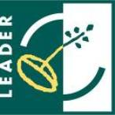
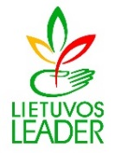

Transnational LAG Cooperation conference
“Networking Works!”

13–14 September, 2017
Vilnius

Project/ Partner Search Template

Strand/Theme | Key words of your project idea (e.g. ecology, branding, social inclusion, etc.)
Deadline | (for application/ for partners)

Organization

Name of LAG
Short project description
Contact details | Name of the organization :  Address :  Tel.:  Email:  Name of the contact person:

Partners searched

Countries | (e. g. all eligible)
Type of LAG | (e. g. all eligible)
Other partners: | (e. g. municipalities; other regional authorities; non-profit organizations, etc.)

Please note that the information you provided will be published on the Lithuanian Rural Networks web page and during the conference.

