

ELARD conference in Estonia
LEADER/CLLD 2020+
22-23 November 2016
Tartu, Estonia

Renewing LEADER/CLLD for 2020+
Celebrating 25 years of LEADER in Europe!

Expected result: Declaration of LEADER/CLLD for the period of 2021–2027 for submitting to the European Commission and the managing authorities of the member states. As the negotiations of the next programming period have already started, it is very important to bring forward the proposals from Leader actors to improve the implementation of LEADER/CLLD.

Registration

Participation fee for members 100 € and 120€ for others. Participation fee includes conference expenses, but not accommodation and travel costs. Online registration will be opened from 15th of September until 31st of October.
Detailed information will be available: www.elard.eu, www.leaderliit.eu .

How to get to Tartu and other important places
- Tips on how to get to Estonia to Tartu http://www.visittartu.com/en/transport/
- With extra fee there is possibility to go to Tartu with study tour that starts from Riga, please contact anita.selicka@gmail.com
- All hotels and other important places related to the Conference are marked on the Google map https://goo.gl/maps/PR4FCA1QJfq .

Transfer to Tartu on 21.11.2016, by bus from Tallinn to Tartu
- There is a good transport connection to Tartu both from Tallinn Coach Station and Tallinn Airport with buses leaving at every full hour between 7:00 and 22:00.
- Tickets can be bought in advance on webpage www.tpilet.ee/en (both printed and mobile tickets are valid, but we recommend to print tickets out). Please mark point of departure Tallinn Airport or Tallinn Coach Station and point of destination Tartu Coach Station.

Transfer to Tallinn on 23/24.11.2016, by bus from Tartu to Tallinn
- Tickets can be bought in advance on webpage www.tpilet.ee/en (both printed and mobile tickets are valid, but we recommend to print tickets out). Please mark point of departure Tartu Coach Station and point of destination Tallinn Airport or Tallinn Coach Station.

Accommodation

- Please find a suitable hotel in the city centre from Google Maps link above: https://goo.gl/maps/PR4FCA1QJfq .
- Please mark selected hotel on the registration form and your accommodation will be booked for you. The hotel will send the booking approval and accommodation invoice directly on your e-mail.
- If you wish to book yourself accommodation with special price, please send your booking to the hotel contact e-mail shown on the given hotel list and Please note that: The keyword of the reservation is "LEADER":

Hotel | Booking by e-mail  Keyword „LEADER“ | One night, with breakfast
Hotel London  http://london.tartuhotels.ee/ | diana.timberg@tartuhotels.ee | room price Sgl 70€,  room price Twin 80€
Art Hotel Pallas,  http://pallas.tartuhotels.ee/ | diana.timberg@tartuhotels.ee | room price Sgl 55€,  room price Twin 67€
Dorpat Hotel,  http://www.dorpat.ee/ | info@dorpat.ee | room price Sgl 59€,  room price Twin 75€
Tartu Hotel  http://tartuhotell.ee/en/ | sales@tartuhotell.ee | room price Sgl 45€,  room price Twin 60€
Barclay Hotel  http://www.barclayhotell.org/ | mailis@barclay.ee | room price Sgl 59€,  room price Twin 75€
Antonius Hotel,  http://hotelantonius.ee/en/ | sales@hotelantonius.ee | room price Sgl 95€,  room price Twin 115€
Villa Margaretha, http://www.margaretha.ee/?page_id=678&lang=en | katre@margaretha.ee | room price Sgl 75€,  room price Twin 80€
Lydia Hotel  http://lydia.ee/en | diana.timberg@tartuhotels.ee | room price Sgl 90€,  room price Twin 112,50
Draakon Hotel  http://www.draakon.ee/eng/hotel.php | draakon@draakon.ee | room price Sgl 49€,  room price Twin 59€

- Hotel check-in starts from 14.00 on arrival day.

Welcome dinner on 21.11.2016
- Informal welcome dinner, which includes brief introduction of the Conference program, will take place in the evening of 21.11.2016 at 20:00 in the Vilde restaurant (Vallikraavi 4, Tartu, www.vilde.ee/eng/restaurant/).

Conference on 22.11.2016
Registration and workshops
- Buses to Conference place leave from the lower parking lot of Vanemuine Theatre at 08:30. We kindly ask everyone to arrive in time
- Registration is opened on 22.11.2016 from 09:00 at The Estonian National Museum (Muuseumi tee 2, Tartu, www.erm.ee).
- The registration card is your "key" to events. Please remember to carry it with you all the time.
- You should select your workshops upon registration.
- You can choose between following topics:
1. CLLD and multi-fund implementation: how to improve its' implementation?
2. Coordination between Leader actors and authorities: how to develop transparent and holistic coordination on national level?
3. Local development strategies: how to assure innovative and flexible implementation?
4. Transnational and inter-territorial co-operation in the EU and with third countries: how to simplify and harmonize the co-operation?
5. 25-year-old LEADER method: how to renew it for 2020+ period?
The workshop presentations and summaries are available on the web after the Conference.

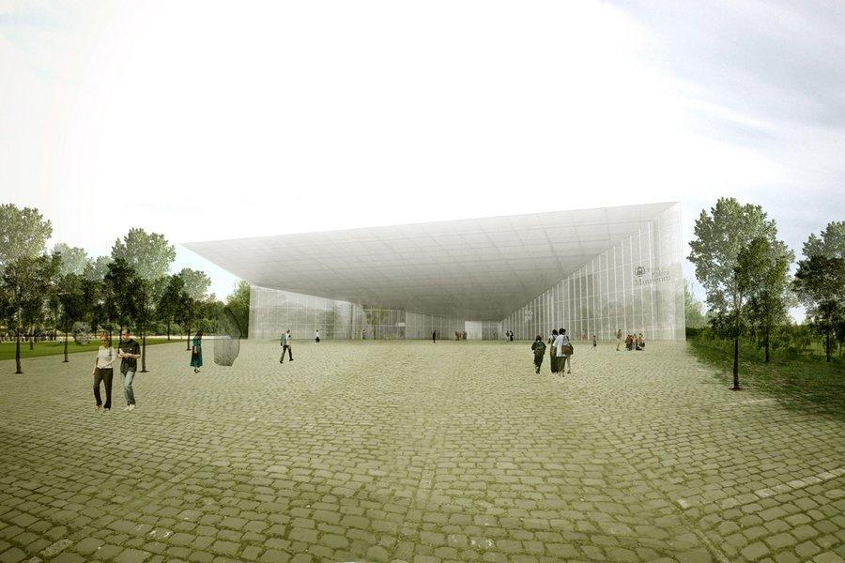
Conference venue - The Estonian National Museum (new building will be opened in October 2016).

Dinner with entertainment program on 22.11.2016
- Dinner on 22.11.2016 will take place in The Folk House at Mooste Manor, Põlva County (www.moostemois.ee/?keel=eng)
- Buses to Mooste leave from the Estonian National Museum at 18:00.
- Buses from Mooste to Tartu will be back starting from 22:00.

Conference on 23.11.2016
- Buses leave from the lower parking lot of Vanemuine Theatre to Conference place at 8:30 am. We kindly ask everyone to arrive in time.
- Shuttle form Conference place to Tartu Coach Station at 15.30 (to get the bus that is leaves from Tartu to Tallinn at 16.00)

Information
- You will find Tartu Tourism Information at Town Hall Square (Raekoja plats) or any hotel reception is also able to help.
- For other events in Tartu: www.kultuuriaken.tartu.ee
- For more information about Tartu: www.visittartu.com
- For more information about South-Estonia: http://visitsouthestonia.com
- For more information about Estonia: www.visitestonia.com

If you have any questions or you wish to receive additional information, contact us: conference@leaderliit.eu, phone: +372 53 461 953.

See you in Estonia!

Organizers: ELARD, Ministry of Rural Affairs, Estonian LEADER Union, Estonian National Rural Network Support Unit, Estonian Village Movement Kodukant.

